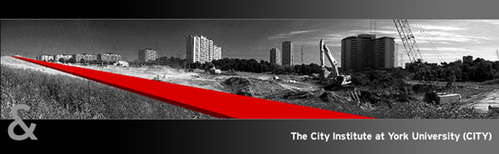

The Global Suburban Infrastructure Workshop

University of Waterloo, June 14-16, 2015

Conference Program (1st draft, June 3, 2015)

Organized by
Major Collaborative Research Initiative (MCRI) on Global Suburbanisms
The City Institute at York University
School of Planning and the Faculty of the Environment
University of Waterloo

Funded provided by a SSHRC Connection Grant, the School of Planning and the Faculty of the Environment of the University of Waterloo, and the Global Suburbanisms MCRI

Sunday June 14, 2015

2:00-6:00: Planning tour of Waterloo Region
The tour will concentrate on recent planning policies in the region including the construction of a LRT, the densification of the central corridor, downtown areas’ revitalization, the hard-edge growth boundary and environmentally sensitive policy areas. The tour will emphasize the position of Waterloo Region within the Toronto commuter shed and transportation connections with Toronto.
The tour will be conducted by Kevin Eby, Director of Community Planning for the Region of Waterloo. More information will be circulated one week before the workshop.
Participants will be picked up at the EV1 building on the University of Waterloo campus and at the entrance of the Delta Hotel on Erb Street in Waterloo.

7:00: Dinner for participants to the workshop
The location of the dinner is at the Bauer Kitchen, which is about a fifteen minute walk from the Delta Hotel. The location is indicated on an aerial photograph at the end of the program.

Monday June 15, 2015 EV1 Room 221

9:00-9:45 Welcoming messages and the organization and purpose of the workshop
Jean Andrey, Dean, Faculty of the Environment, University of Waterloo
Clarence Woudsma, Director, School of Planning, University of Waterloo
Roger Keil, Faculty of Environmental Studies, Principal Investigator of the Global Suburbanisms MCRI
Pierre Filion and Sara Saboonian, School of Planning, University of Waterloo, co-organizers of the workshop

9:45-10:45: Using Infrastructures to Transform suburbs
Chair: Ute Lehrer (York University)
Rebecca Ince and Simon Marvin (University of Durham)
Retrofitting ‘obsolete’ suburbs – networks, fixes and fluidity
Jeff Casello (University of Waterloo)
Suburban infrastructure and transportation choice

10:45-11:00 Coffee break

11:00-12:30: Infrastructure and Suburban development
Chair: Steven Logan (York University)
Xuefei Ren (Michigan State University)
Infrastructure and mobility in urban China: The case of Beijing’s metro network
AbdouMaliq Simone (Max Planck Institute for Ethnic and Religious Diversity)
Relays – Reworking trajectories of articulation among peripheries and cores
Shubhra Gururani (York University)
Landscapes of infra-structure: Urban transformation, development, and neoliberal capitalism in India

12:30-1:30: Lunch in ev1-221 and the adjacent atrium

1:30-3:00: Passenger and Freight Transportation in the suburb
Chair: Frederick Peters (York University)
Steven Logan (York University)
Transportation as transformation: A media analysis of infrastructure
Jean-Paul Addie (University College London)
The three-dimensional dialectics of suburban infrastructure: Scale, centrality, and the spatial politics of Chicago Southland
Clarence Woudsma (University of Waterloo)
Suburbanization, suburbanisms and freight: Infrastructures at the crossroads

3:00-3:30: Coffee break

3:30-5:00: Water infrastructure in the global suburb
Chair: Shubhra Gururani (York University)
Cecilia Alda Vidal, Michelle Kooy and Maria Rusca (UNESCO-IHE)
Opening the black box: Everyday operation of the urban water supply system in Lilongwe, Malawi
Frederick Peters (York University)
Experiments in neoliberal infrastructure: Dynamic capitalist and institutional learning in the neoliberal experiment of post-Soviet Europe
Jonathan Rutherford (Université Paris Est)
Beyond/before infrastructure: Socio-technical disposition and planning for water and wastewater services in the Stockholm archipelago

7:00: Dinner for participants to the workshop
The location of the dinner is at the Faculty Club. The location is indicated on an aerial photograph at the end of the program.

tuesday June 16, 2015 ev1 room 221

9:00-10:30: Social equity issues
Chair: Jeff Casello (University of Waterloo)
Sean Hertel (Urban Planning Consultant, Toronto) and Michael Collens (York University)
Switching tracks: Towards equity in public infrastructure priorities in the Greater Toronto and Hamilton Area
Igor Vojnovic, Jeanette Eckert and Xiaomeng Li (Michigan State University)
Shaping Michigan urban and suburban landscapes of inequity and inequality
Markus Moos (University of Waterloo)
Sustainability as an urban way of living? Equity implications of planners’ interpretation of sustainable infrastructures

10:30-11:00 coffee break

11:00-12:30: Economic, financial and political perspectives
Chair: Markus Moos (University of Waterloo)
Alan Walks (University of Toronto)
The suburban debtscape: Automobility and financial (infra) structures
David Wachsmuth (University of British Columbia)
The ‘in-between territories’ of suburban infrastructure politics
Janice Morphet (University College London)
Rescaling the suburban: New directions in the relationship between governance and infrastructure

12:30-1:30: Lunch in ev1-221 and the adjacent atrium

1:30-3:00 Green and water infrastructure
Chair: Igor Vojnovic (Michigan State University)
Sara Macdonald (York University)
‘Greenfrastructure’: The Ontario Greenbelt as urban boundary
Jochen Monstadt and Martin Schmidt (Techniche Universität Darmstadt)
Suburban governance of water supply and sanitation in the Frankfurt/Rhine-Main region
Sophie Schramm and Lucia Wright Contreras (Techniche Universität Darmstadt)
Suburban constellations of water supply and sanitation in Hanoi

3:00-3:15 coffee break

3:15-4:00: plenary
- Main themes arising from the workshop
- Common dimensions of global suburban infrastructures
- Distinctions between issues related to different types of suburbs and infrastructures
- Connections between empirical and conceptual perspectives
- Conceptual advances in the field of suburban infrastructures
- Contested infrastructures and their impacts
- The organization of the edited University of Toronto Press book

4:00 closure

practical information for the workshop

- The workshop will take place in Room 221 of the EV1 (Environment 1) building on the University of Waterloo campus. You can access a map of the campus at: https://uwaterloo.ca/map/
- Half an hour is awarded for each presentation: twenty minutes for the presentation itself and ten minutes for questions.
- Please upload your presentation on the computer connected to the projector before the session.
- The presentations will be video recorded and uploaded on You Tube with connection to the UW School of Planning and Global Suburbanisms web sites. Please let us know if you would prefer not being recorded. We will then abstain to do so.
- For those who arrive by airplane at Pearson Airport (Toronto) and are going directly to the Waterloo Delta Hotel, Airways Transit will take you to the hotel. This company operates a fleet of mini-buses between Pearson Airport and Waterloo Region. We will provide them with your name and flight arrival time. Don’t worry if your flight is late, Airways Transit monitor arrival times and adjust their service accordingly. For those arriving at Terminal 1, turn to the right when coming out of the baggage claim hall. Walk to the end of the wide corridor (it is a longer walk for people arriving on a domestic flight than for those arriving on an international flight). At the end of the corridor, you will be facing the Good Life Gym installations. You then take the closest escalator going down. At the bottom of the escalator you turn left and go to the counter labelled Ground Transportation. The Airways Transit clerk will have your name on file. For those arriving at Terminal 3 on a domestic flight, you turn right coming out of the baggage claim hall and walk until you arrive at the Ground Transportation desk to your left. For those arriving at Terminal 3 on an international flight, you turn left coming out of the baggage claim room and walk until you arrive at the Ground Transportation desk on your right.
- In Waterloo, we will walk to the different destinations (from the hotel to EV1 and to restaurants where we will have dinner). We would advise you to bring rain gear just in case. If someone has problem walking, please let us know and we will provide a vehicle.
- Unfortunately, as it turns out menu options for the two dinners are more limited than we had hoped. Please let us know if you would like a vegetarian option for the Monday evening dinner. The restaurant would prefer knowing ahead. Moreover, because of funding agency regulations, we will not be able to pay for alcohol (including beer and wine) in the restaurants. Participants will have to pay for their own alcohol consumption. We are sorry about this.
- For reimbursement procedures, please refer to the email sent on June 10th and the attached forms.
- Participants whose home institution is part of the Eduroam system, should be able to connect to University of Waterloo Wi-Fi by entering their usual user ID and password. This procedure sometimes takes a few trials before it works. If they are not able to connect in this fashion, we can provide participants with passwords to access UW Wi-Fi.

Geographic information relevant for the workshop

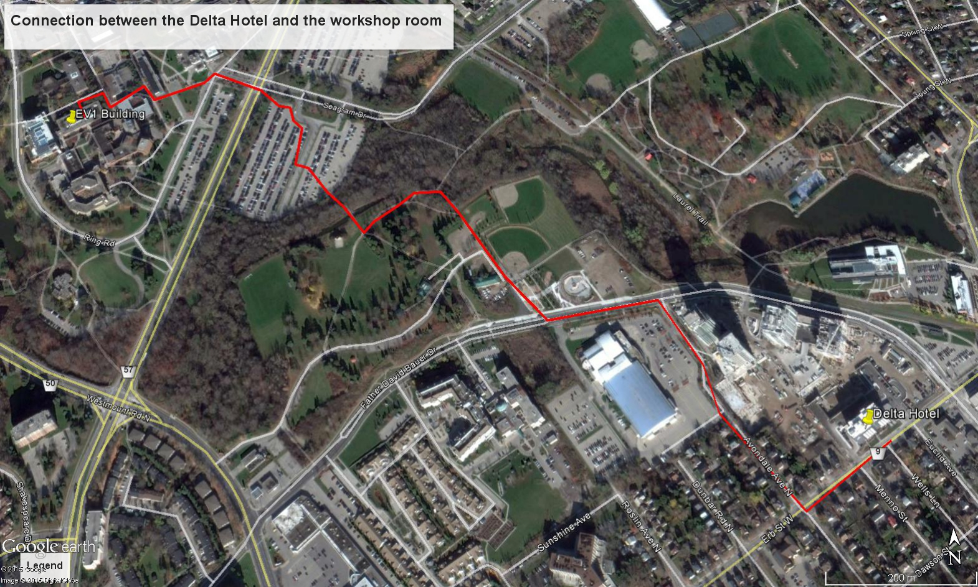
The hotel is approximately a fifteen minute walk from the EV1 Building (Room 221) where the workshop will take place. Sara Saboonian or Pierre Filion will meet you at the lobby of the Delta Hotel at 8:40 am on Monday June 15 and Tuesday June 16. We will walk together to the EV1 building.

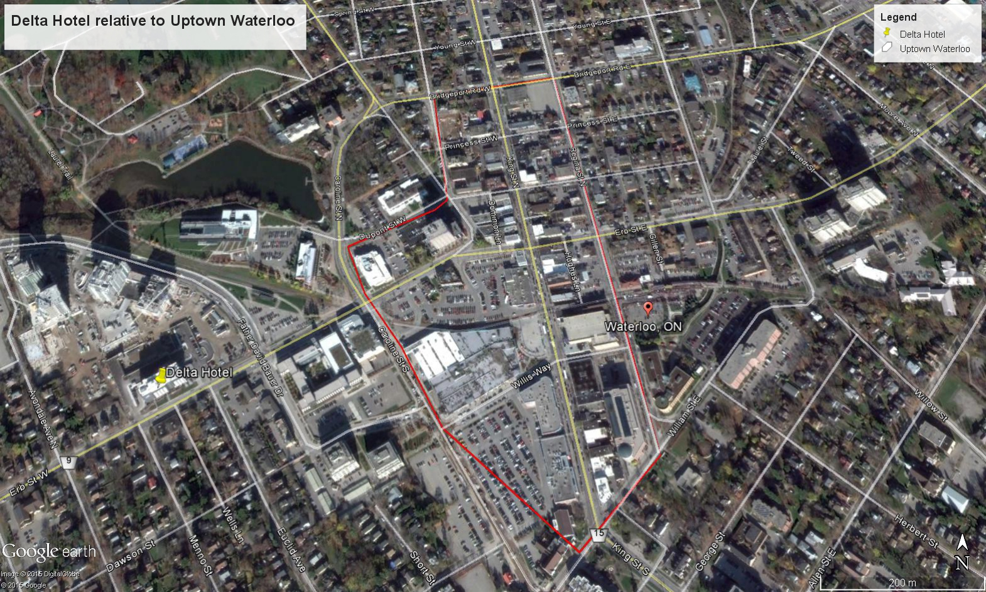
The Delta Hotel is about a five minute walk from Uptown Waterloo where there are restaurants, bars and a supermarket.

