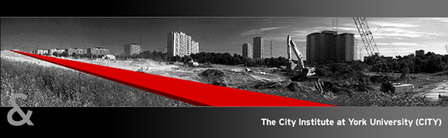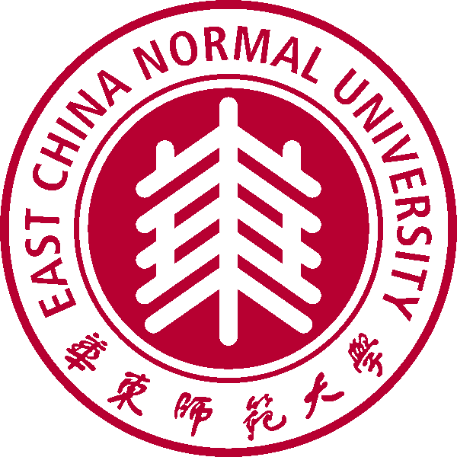

**International Forum on Global Suburbanisms**

**May 9 to 11, 2015**

**Conference Program**

Organized by

Major Collaborative Research Initiative (MCRI) on Global Suburbanisms

The City Institute at York University

Co-organized by

Bartlett School of Planning, University College London

Center for Urban & Regional Studies, Institute of Population Research, Fudan University

Centre for Modern Chinese City Studies, East China Normal University

Institute of Urban and Demographic Studies, Shanghai Academy of Social Sciences

http://www.sshrc-crsh.gc.ca/_Images/fip/logo/SSHRC-CRSH_FIP.jpg

**Saturday May 9, 2015**

**Fieldtrip to Jiading and Wuxi**

8:30 Pick up from [Crowne Plaza Shanghai Fudan](http://www.ihg.com/crowneplaza/hotels/us/en/shanghai/shgfd/hoteldetail) (Please meet in the lobby of the hotel)

9:30 – 12:00 Jiading New town, Shanghai

12:00 Lunch at Jiading

13 :00 Leave Jiading

15:00 – 17:00 Taihu New Town, Wuxi

17:00 Dinner at Wuxi

18:00 Leave Wuxi

19:30 Back to [Crowne Plaza Shanghai Fudan](http://www.ihg.com/crowneplaza/hotels/us/en/shanghai/shgfd/hoteldetail)

**Sunday May 10, 2015**

**Room 919, Wenke Building, Fudan University**

**9:15 – 9:30 Welcome**

**Chair: Jie Shen (Fudan University)**

Guixin Wang (Director of Center for Urban & Regional Studies, Fudan University)

Roger Keil (MCRI Principal Investigator, York University)

Fulong Wu (University College London)

**9:30 – 10:30 Session 1**

**Chair: Fulong Wu (University College London)**

9:30 – 10:00 Ananya Roy (University of California, Berkeley)

*Including the Poor: The Land Question*

10:00 – 10:30 Dan He and Yuemin Ning (East China Normal University) *Evolution of Population Structure and Spatial Distribution in Shanghai since 2000*

**10:30 –11:00 Tea and Coffee Break**

**11:00 – 12:00 Session 2**

**Chair: Zhigang Li (Sun Yat-Sen University)**

11:00 – 11:30 Roger Keil (York University)

*The Global Suburb: Divesting From The World's White Picket Fences*

11: 30 – 12:00 Hongxia Wang and Qiyu Tu (Shanghai Academy of Social Sciences)

*Suburbs Mosaic and its Evolution in Mega Cities of China*

**12:00 – 13:30 Lunch**

**13:30 – 15:00 Session 3**

**Chair: Ute Lehrer (York University)**

13:30 - 14:00 Wang Guixin (Fudan University)

*Urbanization Process of Shanghai: 1990-2010*

14:00 – 14:30 Abidin Kusno (University of British Columbia)

*Imaging / Imagining / Naming the Indonesian Suburb*

14:30 – 15:00 Tian Li (Tongji University)

*From Urban Sprawl to Land Consolidation in Suburban Shanghai: A Perspective of Property Rights Reconfiguration*

**15:00 – 15:30 Tea and Coffee Break**

**15:30 – 17:00 Session 4**

**Chair: Jie Shen (Fudan University)**

15:30 – 16:00 Li Zhang (Fudan University)

*Estimating the value of migration: floating population’s contributions to urban revenue*

16:00 – 16:30 Zhigang Li (Sun Yat-Sen University)

*Assemblage, entrepreneurial suburbanism and the restless (re)making of suburbia in China*

16:30 - 17:00 Paul Bailey, Cara Chellew, Anthony Dionigi, Justin Fok, Victoria Ho, Priscilla Lan Chung Yang, Dilya Niezova, Nelly Volpert and Cathy Zhao (York University)

*Canadian and Chinese urbanism in comparison: some basic ideas*

**18:00 pm – Dinner [Xibei Restaurant, Wanda Plaza, No.503, 5th Floor, 189 Zhengtong Road]**



**Monday May 11, 2015**

**Room 919, Wenke Building, Fudan University**

**9:00 – 11:00 Session 5**

**Chair: Roger Keil (York University)**

9:00 - 9:30 Zhituan Deng (Shanghai Academy of Social Sciences)

*Spatial Distribution, Evolution and Driving Force of Floating Population: A case study of Shanghai city, China, from 2000 to 2010*

9:30 – 10:00 Song Shi (Shanghai Planning Institute)

*Capital Circuit and Competitive Advantage: A theoretical analysis of Impediments of Shanghai’s Urbanization*

10:00 – 10:30 Lan Wang (Tongji University)

*Impacts of High-Speed Train Stations on Suburbanization: An Empirical Study of 22 Cities along Beijing-Shanghai High-Speed Line*

**10:30 -10:45 Tea and Coffee Break**

**10:45 – 13:00 Session 6**

**Chair: Sara Macdonald (York University)**

10: 45– 11:15 Ute Lehrer (York University)

*Reaching New Heights: The Condominium Boom in Toronto*

11:15 – 11:45 Jie Shen (Fudan University)

*Paving the way for growth: rail transit development and suburbanization in Shanghai*

11:45 – 12:15 Nick Phelps (University College London)

*Sequel to suburbia: glimpses of post-suburban America*

12:15 – 13:00 Roger Keil and Fulong Wu

Publication Planning and Conclusion

**13:00 – 14:00 Lunch**

**14:00 – 16:00**

14:00 – 16:00 MCRI Advisory Board meeting

(including MCRI researchers)

**16:30 Pick up from Crown Plaza, the gate of Guoquan Road**

**18:00 Dinner [Ding Tai Fung, No.11A, 2nd floor, 6th Building, Xintiandi Square South, 123 Xingye Road]**

**Directions from Crown Plaza to Wenke Building**

**Hotel address: Crowne Plaza Fudan Shanghai, 199 Handan Road, Yangpu District, Shanghai, 200433**

**Directions From Jinjiang Inn to Wenke Building**

**Hotel address: Shanghai Jinjiang Inn, 236 Guoquan Road, Shanghai**

