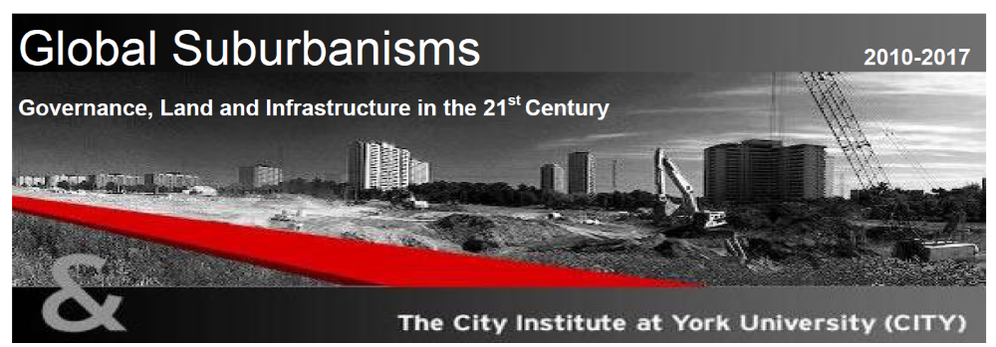
Program - Workshop on Suburban Governance
Leipzig, Germany
June 30 - July 3, 2011

Organizers:
Pierre Hamel (University of Montreal), Roger Keil (York University), Sigrun Kabisch and Dieter Rink (Hemholtz Centre for Environmental Research - UFZ)

Venue:
Helmholtz-Zentrum für Umweltforschung UFZ - Leipziger KUBUS
Permoserstraße 15
D-04318 Leipzig, Germany
Tel: (0341) 235-0
http://www.ufz.de/index.php?de=1405
http://www.leipziger-kubus.ufz.de/

Program

Thursday June 30, 2011
Arrival in Leipzig, Germany

19:00: Dinner at Auerbach’s Keller.
http://www.auerbachs-keller-leipzig.de/content.php?lang=en

Friday July 1, 2011
Room: Hall 2 AB

9:00 - 9:30: Welcome: Roger Keil and Sigrun Kabisch

9:30-10:00: (Chair: Ute Lehrer) Introduction to the workshop.
“Governing Suburbia: Modalities and Mechanisms of Suburban
Governance” - Pierre Hamel and Roger Keil; Discussant: Robert
Young

10:00-10:30: (Chair: Pierre Hamel) “Governance, Economy, Society” - Jamie
Peck; Discussant: Fulong Wu

10:30-11:00: (Chair: Roger Keil) “Governance of Suburban Shrinkage" - Sigrun Kabisch, Matthias Bernt, Dieter Rink; Discussant: Ludek Sýkora

11:00-11:15: Coffee Break

11:15-12:15: (Chair: Will Poppe) “Suburban governance in Eastern Europe” –
Sonia Hirt; Discussant: Dieter Rink

12:15-14:00: Lunch at UFZ Kantine

14:00-15:00: (Chair: Will Poppe) “Suburban governance in Africa” - Robin Bloch; Discussant: Jan Nijman

15:00-16:00: (Chair: Roger Keil) “Suburban governance in South Asia” -Shubhra
Gururani; Discussant: Ananya Roy

16:00-16:15: Coffee Break

16:15-17:15: (Chair: Shubra Gururani) “Suburban governance in China” - Fulong Wu; Discussant: Terry Mc Gee

19:30: Optional tour of microbrewery at Bayerischer Bahnhof
http://www.bayerischer bahnhof.de/de/startseite/index.html

20:00: Dinner at Bayerischer Bahnhof
http://www.bayerischer bahnhof.de/de/startseite/index.html

Saturday July 2, 2011
Room: Hall 2 AB

9:00 - 10:00: (Chair: Pierre Hamel) “Suburban Governance in Latin America”-
Dirk Heinrichs, Henning Nuissl and Emilio Berrios; Discussant:
Will Poppe

10:00-11:00: (Chair: Ute Lehrer) “Suburban governance in Western Europe” –
Nick Phelps and Amparo Tarazona Vento; Discussant: Dirk
Heinrichs

11:00-11:15: Coffee Break

11:15-12:15: (Chair: Nick Phelps) “Suburban governance in the United States” –
Jan Nijman; Discussant: Roger Keil

12:15-14:00: Lunch - Catering at venue

14:00-15:00: (Chair: Will Poppe) “Suburban governance in Canada” (Pierre
Hamel and Roger Keil); Discussant: Douglas Young

15:00-16:00: (Chair: Pierre Hamel) “Lessons from the case studies: elements of
synthesis”

16:00-16:15: Coffee Break

16:15-17:15: (Chair: Roger Keil) Book project - comments (Terry Mc Gee,
Ananya Roy, Robert Young) and guidelines

Summary and Closing Comments

19:30: Dinner Schrebers beergarden and restaurant http://www.schrebers.com/

Sunday July 3, 2011
Optional: Tour of Leipzig and surroundings

